East Blue Hill Village Improvement Association Board of Directors
(draft) HANDBOOK
www.eastbluehill.org

Introduction 3
Mission Statement 4
Bylaws 5
Board Member Expectations 13
Responsibilities 14
Fiduciary Responsibilities 14
Checklist of Annual Actions 14
Useful Nonprofit Links 14
Maine Guide for Board Members of Charitable Corporations 15
Filing and Reporting Requirements 18
Financial Statements 20
Real Estate Holdings 21
Property Owned By EBHVIA 21
Property on Which EBHVIA Holds an Easement 21
Property Owned by the East Blue Hill Library Association 21
Policies 22
Robert’s Rules of Order Cheat Sheet 23
Roberts Rules of Order Cheat Sheet 24
Agenda Template 25
Minutes 26
VIA Board Roster 27
VIA Directory 28
History of EBHVIA 29
History of Village by Jerry Long 30
Calendar of Events and Responsibilities………………………………………………………..31

Introduction

Welcome to the East Blue Hill Village Improvement Association Board of Directors!

This handbook provides you with basic information about the East Blue Hill Village Improvement Association and your role on the board. Please take time to familiarize yourself with the mission, bylaws and financial statements. East Blue Hill is a small and beautiful village, and we need every board member to be effective and well informed in order to take care of this little stretch of the coast. With our help East Blue Hill will continue to preserve the history and quiet beauty of the town, as well as encourage vibrant village life for years to come. Thank you for being a part of the process.

Mission Statement

Consistent with its Articles of Incorporation, as amended, the mission of the EBHVIA is to promote the East Blue Hill community and maintain for the village of East Blue Hill properties owned by the EBHVIA.

Bylaws

Approved August 11, 2020

ARTICLE I. CORPORATE STATUS

The East Blue Hill Village Improvement Association (hereinafter EBHVIA) is a non-profit corporation organized pursuant to the laws of the State of Maine that has been granted 501(c)(3) status by the United States Internal Revenue Service. Its principal place of business is the area of the Town of Blue Hill, Hancock County, Maine known as East Blue Hill.

ARTICLE II. MISSION

Consistent with its Articles of Incorporation, as amended, the mission of the EBHVIA is to promote the East Blue Hill community and maintain for the village of East Blue Hill properties owned by the EBHVIA.

ARTICLE III. MEMBERSHIP

- Eligibility. Membership is open to anyone who owns or rents property or lives in East Blue Hill, is sixteen [16] years of age or older and has paid the annual dues. East Blue Hill (hereinafter called the village) is a section of Blue Hill bounded by the Surry town line on the Morgan Bay Road and the Esther Woods House at 456 East Blue Hill Road inclusive, at Friends Corner.

B. Requirements. To become a Member, an eligible person must apply to the organization's Board of Directors and pay annual dues. The period of membership shall be the calendar year. To renew membership, current members must pay dues prior to the 30th of April. For new members the privilege of voting shall commence two months after the receipt of payment of dues. The application form and the amount for payment of the annual dues shall be established by the Board of Directors.

C. Rights and Responsibilities. The Rights and Responsibilities of membership shall include:
1. Voting to Elect the Chair, Vice Chair, Secretary and Treasurer of the membership who shall serve as the Officers of the Board of Directors;
2. Voting to Elect the remainder of the Board of Directors;
3. Voting to Approve amendments to these By-Laws and the Articles of Incorporation;
4. Voting on the affairs of the EBHVIA at membership meetings;
5. Participating as volunteers in the affairs and activities of the EBHVIA, including serving on committees, and sharing information and ideas with the EBHVIA.

ARTICLE IV. MEETINGS

A. Annual Meeting. An Annual Meeting of the Membership shall be held each year at a time and place as determined by the Board of Directors. A quorum shall be fifteen Members with voting privileges. Approval of any proposed action shall require a majority vote of those Members attending, except that pursuant to Article XII any amendment to these By-laws or to the Articles of Incorporation shall require approval by a two-thirds (2/3) vote of the members present, and pursuant to Article X no interest of the EBHVIA in any real estate may be transferred, exchanged, encumbered, or in any other way alienated, unless authorized by a vote of at least three quarters (3/4) of the members present. For elections of Directors, when there are more candidates nominated than the number of positions to be filled, a written ballot shall be provided.

- Special Meeting. A Special Meeting of the Membership may be called by the Board of Directors, or by petition of ten Members in good standing, at a time and place determined by the Board of Directors, for the purpose of acting on any issues that require approval by the Membership. If a Special Meeting is called by a petition of ten Members, then the meeting shall occur no later than twenty-one days after the Board's receipt of the petition. A quorum shall have fifteen members with voting privileges. Approval of any proposed action shall adhere to the requirements of an Annual Meeting of the membership.
- Regular Meetings. Regular Meetings of the membership of the EBHVIA shall be held on the second Tuesday of the month, no less frequently than quarterly, at a time and place designated by the Chair. These meetings are open to the public. Voting is reserved for members only. Issues brought before the regular meetings shall be resolved by a majority of the voting members in attendance. At any regular meeting of the members a quorum for the transaction of business shall consist of five or more members provided that less than such quorum shall have the power to adjourn the meeting.

D. Board Meetings. Regular meetings of the Board of Directors of the EBHVIA shall be held on the second Tuesday of the month, no less frequently than quarterly, at a time and place designated by the Chair. Voting is reserved for board members only. Issues brought before the board shall be resolved by a majority of the voting members of the board in attendance. A quorum shall consist of no less than five of the currently serving Directors. Unless otherwise specified in these bylaws or the laws of the State of Maine, a majority vote of the directors present shall be required to approve any resolution or action by the board.
E. Notice of Meetings. Notice of all meetings of the EBHVIA shall be made available not less than seven days prior to the scheduled meeting. Notice will include the proposed agenda for the meeting, the minutes of the previous meeting and the link to provide electronic attendance. Minutes of all meetings of the EBHVIA shall be available to the members on the website or upon request.
F. List of Members. A list of members with voting privileges shall be available at all meetings of the EBHVIA.

G. Attendance. For quorum and voting purposes, a member must be physically or electronically present at any meeting. Attendance electronically shall be via an agreed upon audio-visual group meeting system (platform) allowing the electronically present member to be heard by those attending in person and to hear those attending in person.
All meetings of the EBHVIA are open to the public.

H. Robert’s Rules of Order. All meetings of the EBHVIA will be run according to Robert’s Rules of Order.

- Voting. Voting by members attending electronically shall be in a recordable format via the electronic group platform. Anonymous (secret ballot) votes will be done by email vote to the secretary only. Proxy voting shall not be permitted. At all meetings, issues brought to a vote shall be considered resolved at the time of the vote.

ARTICLE V. BOARD OF DIRECTORS
A. General Powers. As provided by Maine law, the affairs of the EBHVIA shall be managed by its Board of Directors. The Board shall have and may exercise all the powers allowed to nonprofit corporations under the laws of the State of Maine except as may be limited by the provisions of these By-Laws or the EBHVIA's Articles of Incorporation.

B. Board Role. The board is responsible for overall policy and direction of the EBHVIA, and delegates responsibility of day-to-day operations to the membership and its membership committees. The board shall not approve of an action for the policies, management or direction of the EBHVIA unless such action has been previously approved by the membership. The vote of the board shall be the final determination of an action to be decided. In the event of a tie vote from the board, the decision of the membership on the question shall be determinative.

C. Specific Responsibilities. Subject to the provisions of Section 2 above, the management responsibilities of the Board of Directors shall include but not be limited to the following:
1. Ensuring that all activities of the EBHVIA are consistent with these bylaws.
2. Ensuring the compliance of the EBHVIA with all federal, state and local laws and ordinances, including annual corporate filings with the State of Maine and the Internal Revenue Service as required by law.
3. Appointment of a person to serve as the 'noncommercial registered agent' for the EBHVIA as required by the State of Maine for all nonprofit corporations.
4. Management of the finances of the EBHVIA, including preparation and oversight of an annual budget and investment of the financial assets of the EBHVIA.
5. Stewardship of the real estate assets of the EBHVIA, including buildings and land.
6. Establishment and appointment of standing committees and special committees as needed.
7. Keeping accurate minutes of its meetings and making those minutes available to the Membership.
8. Ensuring that all records of the affairs of EBHVIA are safely kept.
9. Maintaining a website or other electronic communication vehicle for communications with the Membership.
10. Ensuring that notices of meetings and events are posted at various locations throughout the Village where they can be easily seen and are readily accessible.
11. Ensuring that all business of the EBHVIA is conducted with openness and transparency.
D. Composition of the Board of Directors. The Board of Directors, including the officers, shall consist of not less than seven and not more than eleven persons, who shall be members of the EBHVIA.

E. Nomination. A nominating committee of members shall be responsible for nominating a slate of prospective board members including officers representing the EBHVIA’s diverse constituency. In addition, any member can nominate a candidate to the slate of nominees by submitting that candidate’s name to the committee not less than 14 days prior to the annual meeting.

F. Term of Office. The term of office of a Director shall be for one year. A Director may serve only six consecutive terms, but may be re-elected after an absence from the Board of one year or more. Following their election, the members of the Board of Directors shall immediately assume their elected roles and lead the remainder of the annual meeting.

G. Election. Officers and directors shall be elected or re-elected by the members at the annual meeting of the membership. Officers and directors will be elected by a simple majority vote of members present.

H. Vacancies. A vacancy of an officer or director, however occurring, in any office may be filled by a majority vote of the members present at the next regular meeting of the membership or at a special meeting.

I. Resignation and Removal. Resignation from the board must be in writing and received by the Secretary of the Board of Directors. A board member may be removed for any reason by a two-thirds vote of the remaining Directors. A Director may be removed with or without cause by the Membership by a majority vote of the Members attending a Special Meeting of the Membership called for that purpose.

J. Officers and Duties. There shall be four officers of the board, consisting of a chair, vice-chair, secretary and treasurer.
1. Chair. The Chair shall exercise general supervision of the affairs of the corporation, shall preside at all meetings of the members and the Board of Directors and generally shall perform the duties as prescribed by vote of the Board of Directors. The Chair shall present at each annual meeting of the membership an annual report of the work of the EBHVIA.
2. Vice-Chair. The Vice-Chair shall have such powers and duties as may be assigned by the Board from time to time. In the absence or impairment of the Chair, or at the request of the Chair, the duties of the Chair shall be performed by the Vice Chair. The Vice Chair shall then become acting chair of the organization with all the rights, privileges and powers as if duly elected and generally shall perform the duties usually incident to the office or as prescribed by vote of the membership. The acting chair shall yield the role upon return of the chair upon request.

3. Secretary. The Secretary shall notify all members of the annual, special and regular meetings of the membership and meetings of the Board of Directors. Notices shall be furnished in the manner provided by these bylaws. The Secretary shall faithfully and impartially record the actions taken at each meeting of the members. The secretary shall receive and tabulate all secret ballots submitted digitally via email. The Secretary shall have custody of the corporate records and the corporate seal. The Secretary shall ensure the maintenance of an accurate membership list, contact addresses and email addresses for all members of the corporation, Directors and executive officers of the EBHVIA. The Secretary shall also act in place of and for the Chair in the event that, by reason of absence or disability, the Chair and the Vice-Chair are unable to perform their duties.

4. Treasurer. The Treasurer shall have responsibility for oversight of the receipt and custody of the EBHVIA's funds, keeping accurate and complete records of all receipts and disbursements of the EBHVIA, presentation of financial reports to the Board of Directors and the members at least quarterly, preparation, distribution and retention of all reports, records and returns required by the Board and by law, submission of a financial statement of the EBHVIA's preceding year at each Annual Meeting of the Membership and performance of such other duties as may be assigned by the Board from time to time. The Treasurer shall serve as chair of the Finance Committee. Further requisite activities for this office are presented in the Handbook.

K. Compensation. The members of the Board of Directors shall receive no compensation for their work as members of the board.

ARTICLE VI. COMMITTEES

A. Executive Committee. There shall be an Executive Committee which shall be composed of the Officers of the EBHVIA and one other director appointed by the Board of Directors. The Executive Committee shall act for the Board, as needed, during the period between Board meetings and shall be subject to the direction and control of the full Board. The Executive Committee shall be granted the privilege to sign checks and/or other orders for the payment of money and to execute promissory notes or other evidences of indebtedness of the EBHVIA, provided that any such check, payment or indebtedness instrument shall require two authorized signatures if greater than an amount to be determined by the Board. The Executive Committee shall have passwords to the website and accounting software. It may exercise all of the powers of the Board, except it shall have no power to:
1. amend, repeal or replace these By-Laws, the Articles of Incorporation, or any policy adopted by the Board;
2. amend or repeal any resolution approved by the Board; or
3. exercise any power specifically reserved to the Board by these By-Laws or by a resolution of the Board.
A majority of the Executive Committee shall constitute a quorum at its meeting and any action shall require the affirmative vote of the majority of those present but in no case may such majority be fewer than three persons.
The Executive Committee shall ensure the creation and periodic maintenance of a handbook describing the functions of the EBHVIA and approve all changes to the handbook.

B. Finance Committee. The Finance Committee shall be a committee of Board of Directors. The committee chair shall be the treasurer.

C. Committee Formation. Other committees may be created at any membership meeting by majority vote of the members present. Committee Heads shall be appointed by the Chair. The Head of each committee shall be a member of the EBHVIA. Other persons serving on committees may include members of the EBHVIA and members of the public.

D. Committee Reports. Committees shall provide written reports of their activities and recommendations at the next appropriate meeting of the membership of the EBHVIA.
Article VII. FINANCIAL MANAGEMENT

A. Fiscal Year. The fiscal year of the EBHVIA shall be the calendar year beginning on the first day of January and ending on the thirty-first day of December.
Bank and Investment Accounts. The Board is authorized to select the banks, depositories or investment organizations it deems proper for the funds of the EBHVIA. The board shall determine who shall be authorized on the EBHVIA’s behalf to write checks or other orders for the payment of money and to execute promissory notes or other evidence of indebtedness provided that such check, payment or indebtedness instrument shall require two (2) authorized signatures if in the amount greater than an amount established by the board at an annual meeting. The Board shall ensure that the names of the persons authorized to write checks on behalf of EBHVIA are updated as necessary with all the appropriate financial institutions.

ARTICLE VIII. INDEMNIFICATION AND INSURANCE

A. Indemnification. The EBHVIA shall to the fullest extent now or hereafter permitted by the laws of the State of Maine indemnify any person made, or threatened to be made, a party to any action or proceeding by reason of the fact that he or she is or was a Director, Officer, or employee of the EBHVIA, from and against any and all judgments, fines, amounts paid in settlement and reasonable expenses, including attorney fees.
No indemnification may be made to or on behalf of any person if:
1. their acts were committed in bad faith or were the result of their active and deliberate dishonesty and were material to such action or proceeding; or
2. they personally gained a financial profit or other advantage to which they were not legally entitled.

B. Insurance. The Board of Directors shall cause to be purchased and maintain insurance to indemnify the EBHVIA for any expense it incurs as a result of the obligation to indemnify the Directors, Officers, and employees of the EBHVIA pursuant to Section 1 above.
ARTICLE IX. CONFLICTS OF INTEREST

Any person in a position to exercise substantial influence over the affairs of the EBHVIA, including but not limited to Officers, Directors, Committee Members and substantial donors, shall have a duty of loyalty to the EBHVIA. If a person's duty of loyalty comes into conflict with a competing financial or personal interest that they or a related party may have with respect to an existing or proposed project or transaction of the EBHVIA, that person must disclose that actual, potential or perceived conflict of interest to the Chair, Executive Committee or the chairperson of the committee on which they serve. The non-conflicted Members of the Board of Directors shall determine if a conflict of interest exists. Until such determination, such person shall abstain from any discussions of the project or transaction and any votes with respect to the project or transaction. Reimbursement paid to any person for incidental expenses associated with the business of the EBHVIA or compensation paid to any employee or contractor shall not give rise to a conflict.

ARTICLE X. TRANSFER OF HOLDINGS

No interest of the EBHVIA in any real estate may be transferred, exchanged, encumbered or in any other way alienated, unless authorized by vote of at least three quarters (3/4) of the Members attending an Annual or at Special Meeting of the Membership called for that purpose.

ARTICLE XI. DISSOLUTION
Upon dissolution or closing of the affairs of the EBHVIA, whether voluntary or involuntary, the assets of the EBHVIA, after all debts have been satisfied, shall be distributed exclusively to such charitable organizations as shall be designated by a majority vote of the Board of Directors, provided however that any such recipient organization shall be a Maine non-profit granted 501c)(3) tax status by the Internal Revenue Service or a Maine governmental agency.

ARTICLE XII AMENDMENTS

Any amendment to these By-laws or the Articles of incorporation shall require approval by a two-thirds (2/3) vote of the Members attending an Annual Meeting or a Special Meeting called for that purpose.

END OF BYLAWS

(January 10, 2019 DRAFT #6 )
BY-LAWS OF EAST BLUE HILL
VILLAGE IMPROVEMENT ASSOCIATION

ARTICLE I. CORPORATE STATUS
The East Blue Hill Village Improvement Association (hereinafter EBHVIA) is a non-profit corporation organized pursuant to the laws of the State of Maine that has been granted 501(c)(3) status by the United States Internal Revenue Service. Its principal place of business is the area of the Town of Blue Hill, Hancock County, Maine known as East Blue Hill.
ARTICLE II. MISSION
Consistent with its Articles of Incorporation, as amended, the mission of the EBHVIA is......
ARTICLE III. MEMBERSHIP
- Eligibility. Any person 16 years of age or older who resides year-round or seasonally in the part of the Town of Blue Hill bounded by the Surry Town Line on the Morgan Bay Road/Rte. 176 and by and including the property at 456 East Blue Hill Road (the former Esther Woods property) at Friends Corner, so-called, (hereinafter “the Village”) may become a Member.

- Requirements. To become a Member, an eligible person must apply to the organization's Board of Directors and pay annual dues. Both the application form and the amount of the annual dues shall be established by the Board of Directors.

- Responsibilities. Members have the following responsibilities:
- Elect the Board of Directors;
- Elect from the Board of Directors the President, Vice-President, Secretary and Treasurer of the EBHVIA, all of whom shall serve as the Officers of the Board of Directors;
- Approve amendments to these By-Laws and the Articles of Incorporation;
- Participate as volunteers in the affairs and activities of the EBHVIA and the Village community, including serving on committees established by the Board, and sharing information and ideas with the Board.

ARTICLE IV. MEETINGS OF THE MEMBERSHIP
- Annual Meeting. An Annual Meeting of the Membership shall be held each year at a time and place that will result in high Member attendance, as determined by the Board of Directors, at which the Board of Directors and Officers of the EBHVIA shall be elected, and any proposed amendments to the By-Laws and any other issues that require a vote of the Membership shall be acted upon. A quorum shall be fifteen Members. Approval of any proposed action shall require a majority vote of the Members in attendance. All Annual Meetings shall be conducted according to Roberts Rules of Order.

- Special Meetings. A Special Meeting of the Membership may be called by the Board of Directors, or by petition of ten Members in good standing, at a time and place determined by the Board of Directors, for the purpose of acting on any issues that require approval by the Membership. If a Special Meeting is called by a petition of ten members, then the meeting shall occur no later than twenty-one days after the Board’s receipt of the petition. A quorum shall be fifteen Members. Approval of any proposed action shall require a majority vote of the Members in attendance. All Special Meetings shall be conducted according to Roberts Rules of Order.

- Member Forums. The Board of Directors shall schedule at least four Member Forums per calendar year to provide an opportunity for any and all Members to discuss issues affecting the Village or the EBHVIA and to make recommendations to the Board of Directors. The President or another Board Member designated by the President shall prepare the agenda and preside at these Forums, which shall be advisory in nature and shall not require a quorum.

- Meeting Notices and Minutes. Notice of the date, time and place of the Annual Meeting shall be distributed to the Membership no later than January 1 of each year. Additional notice of the date, time, place and agenda of the Annual Meeting, and of any Special Membership meeting and of all Member Forums, shall be provided to the Members not less than ten days before the date of the meeting. Minutes of all Membership Meetings and Forums shall be taken and distributed to the Board and the Membership.

ARTICLE V. BOARD OF DIRECTORS
- General Powers. As provided by Maine law, the affairs of the EBHVIA shall be managed by its Board of Directors. The Board shall have and may exercise all the powers allowed to nonprofit corporations under the laws of the State of Maine except as may be limited by the provisions of these By-Laws or the EBHVIA's Articles of Incorporation.

- Specific Responsibilities. Subject to the provisions of Section V.A above, the management responsibilities of the Board of Directors shall include but not be limited to the following:
- Management of the finances of the EBHVIA, including preparation and oversight of an annual budget and investment of the financial assets of the EBHVIA.
- Stewardship of the real estate assets of the EBHVIA, including buildings and land.
- Establishment and appointment of standing committees and special committees as needed.
- Ensuring the EBHVIA's compliance with all federal, state and local laws and ordinances, including annual corporate filings with the State of Maine and the Internal Revenue Service as required by law.
- Appointment of a person to serve as the ‘noncommercial registered agent’ for EBHVIA as required by the State of Maine for all nonprofit corporations.
- Keeping accurate minutes of its meetings and making those minutes available to the Membership.
- Ensuring that all records of the affairs of EBHVIA are safely kept.
- Ensuring that all activities of the EBHVIA and the Board are consistent with these By-Laws.
- Maintaining a website or other electronic communication vehicle for communications with the Membership.
- Ensuring that notices of meetings and events are posted at various locations throughout the Village where they can be easily seen and are readily accessible.
- Ensuring that all business of the EBHVIA is conducted with openness and transparency.

- Composition. The Board of Directors shall consist of not less than seven and not more than eleven persons, including the Officers, all of whom shall be Members of the EBHVIA and a majority of whom shall be year-round residents of the Village.

- Election and Terms. To become a Director, a person shall be nominated by the Board or by any Member of the EBHVIA and elected by a majority of the Members in attendance and voting at the EBHVIA's Annual Meeting or at a Special Meeting of the Membership called for that purpose. The term of office of a Director shall generally be for three years; however, to ensure continuity in the functioning of the Board, the Board shall cause one third of the Directors' terms to expire each year, and to accomplish such purpose, Directors may be elected for terms of less than three years. A Director may serve only two consecutive terms, a maximum for six years, but may be re-elected after an absence from the Board of one year or more following the completion of two terms.

- Removal. A Director may be removed from the Board by a vote of three-fourths of the persons serving on the Board if the Director has two or more unexcused absences from Board meetings in a single year. A Director may be removed with or without cause by the Membership by a majority vote of the Members attending the Annual Membership Meeting or at a Special Meeting of the Membership called for that purpose.

F. Meetings
1. Number, schedule and notice. The Board of Directors shall meet at least four times per calendar year, with the schedule of the year's meetings (date, time and place) distributed to the Membership no later than January 1 of each year. Additional notice of each scheduled meeting and the meeting agenda shall be provided to the Members at least ten days in advance of the meeting date. Special Meetings of the Board may be called by the President or on request of four Directors filed with the Secretary, with prior notice provided to the Membership of the date, time, place and purpose of the meetings at least ten days in advance; however if it is determined by the President that an emergency exists that does not allow for the 10 day notice period, a shorter notice period is allowed. Notice may be given by any means, including electronic, that effectively reaches the Membership in timely fashion.

2. Attendance by Directors. Directors shall attend meetings in person whenever possible; however, Directors may participate by phone or other electronic means provided that all participating Directors can hear each other. The minutes of each meeting shall record which Directors were in attendance, which if any were absent but excused, and which if any were absent and unexcused. A Director shall be considered excused if notification of the Director’s necessary absence is received by the President or Secretary prior to the meeting.

3. Quorum, Voting and Rules. A quorum shall consist of five Directors. Unless otherwise specified in these By-Laws or the laws of the State of Maine, a majority vote of the Directors present shall be required to approve any resolution or action by the Board. Meetings shall be conducted according to Roberts Rules of Order.

4. Attendance by Members and Opportunity for Comment. All meetings of the Board of Directors shall be open to the Members and there shall be time on the agenda of every Board meeting for Members to speak. However, only Directors may vote on any proposed resolution or action.

5. Minutes. Minutes of all meetings of the Board of Directors shall be taken and distributed to the Membership.

ARTICLE VI. OFFICERS

- The Officers of the EBHVIA shall be a President, a Vice-President, a Secretary and a Treasurer. All Officers shall be Directors and shall be elected by the Membership. Each Officer shall serve a term of office of one year or until a successor is elected, and any Officer may serve no more than four consecutive terms. If a vacancy occurs before the expiration of an Officer's term, the Board may elect one of the Directors as an interim successor to complete the term. An Officer may be removed with or without cause by an affirmative vote of three-fourths of the Directors.

- President. The President of the EBHVIA shall serve as the Chair of the Board of Directors, and shall preside at all meetings of the Membership, the Board of Directors, and the Executive Committee. The President shall exercise general supervision over the management of the property and affairs of the EBHVIA and shall perform such other duties as may be assigned by the Board from time to time. The President shall have authority to sign in the name of the EBHVIA all contracts authorized generally or specifically by the Board, unless the Board has specifically required an additional signature. The signature authority of the President may be delegated to another Officer by resolution of the Board.

- Vice-President. The Vice-President shall have such powers and duties as may be assigned by the Board from time to time. In the absence of the President, the Vice-President shall perform the duties of the President.

- Treasurer. The Treasurer shall have responsibility for the following: oversight of the receipt and custody of the EBHVIA's funds; keeping accurate and complete records of all receipts and disbursements of the EBHVIA; presentation of financial reports to the Board at least quarterly; preparation, distribution and retention of all reports, records and returns required by the Board or by law; submission of a financial statement of the EBHVIA's preceding year at each Annual Meeting of the Membership; and performance of such other duties as may be assigned by the Board from time to time. The Treasurer shall serve as chair of the Finance Committee.

- Secretary. The Secretary shall keep and distribute to the Members and Directors, or cause to be kept and distributed, minutes of the Annual Meeting of the Membership, all Special Meetings of the Membership and all Member Forums, as well as minutes of all meetings of the Board and of the Executive Committee. The Secretary shall be responsible for distributing notices of all meetings and forums of the Membership, and meetings of the Board and Executive Committee. The Secretary shall be responsible for keeping accurate Membership records and ensuring that a list of current Members is available at all Annual and Special Meetings. The Secretary shall be responsible for keeping a roster of the Directors and each Director’s term of service. In the absence of the Secretary at any meeting, a person appointed by the presiding Officer at that meeting shall keep the minutes. The Secretary shall also act in place of and for the President in the event that, by reason of absence or disability, the President and the Vice-President are unable to perform their duties.

ARTICLE VII. COMMITTEES

- Executive Committee. There shall be an Executive Committee which shall be composed of the Officers of the EBHVIA and one other Director appointed by the Board. The Executive Committee shall act for the Board, as needed, during the period between Board meetings and may exercise all of the powers of the Board, except it shall have no power to (1) amend, repeal or replace these By-Laws, the Articles of Incorporation or any policy adopted by the Board; (2) amend or repeal any resolution approved by the Board; or (3) exercise any power specifically reserved to the Board by these By-Laws or by a resolution of the Board. A majority of the Executive Committee shall constitute a quorum at its meetings and any action shall require the affirmative vote of a majority of those present but in no case may such majority be fewer than three persons. Reasonable prior notice shall be given to the Membership and Directors of any meeting of the Executive Committee, and minutes of any such meeting shall be taken and distributed to the Membership.

- Finance Committee. There shall be a Finance Committee to plan and organize fundraising activities and provide assistance to the Treasurer and the Board in reviewing and guiding the financial affairs of the EBHVIA. This committee shall be composed of persons appointed by the Board and may include Members of the EBHVIA who are not Directors.

- Building and Grounds Committee. There shall be a Buildings and Grounds Committee to plan and lead the work of maintaining the buildings and stewarding the land owned or overseen by the EBHVIA, including any easements. It shall have only those powers specifically delegated to it by the Board. Any activity planned or recommended by the Committee that may have financial costs or implications for the EBHVIA shall be approved by the Board. The Committee chair and the persons serving on the Committee shall be appointed by the Board and may include Members of the EBHVIA who are not Directors.

- Other Committees. The Board may establish and appoint other standing, ad hoc or special committees with such composition, duties and powers as the Board may prescribe. The chair of each such committee and the persons serving on it shall be appointed by the Board and may include Members of the EBHVIA who are not Directors.

- Minutes. Each Committee shall keep minutes of its meetings and report the same to the Board of Directors.

- Notice. Prior notice of the date, time and place all Committee meetings shall be provided to the Membership. All Committee meetings shall be open to all Members of the EBHVIA.

ARTICLE VIII. FINANCIAL AFFAIRS

- Fiscal Year. The fiscal year of the EBHVIA shall be the calendar year, beginning on the first day of January and ending on the thirty-first day of December each year.

- Bank and Investment Accounts. The Board is authorized to select the banks, depositories or investment organizations it deems proper for the funds of the EBHVIA. The Board shall determine who shall be authorized on the EBHVIA's behalf to write checks or other orders for the payment of money and to execute promissory notes or other evidences of indebtedness, provided that any such check, payment or indebtedness instrument shall require two authorized signatures if in an amount over five hundred dollars ($500).The Board shall ensure that the names of the persons authorized to write checks on behalf of EBHVIA are updated as necessary with all the appropriate financial institutions.

ARTICLE IX. INDEMNIFICATION AND INSURANCE

The EBHVIA shall, to the fullest extent now or hereafter permitted by the laws of the State of Maine, indemnify any person made, or threatened to be made, a party to any action or proceeding by reason of the fact that he or she was a Director, Officer, or employee of the EBHVIA, from and against any and all judgments, fines, amounts paid in settlement and reasonable expenses, including attorney fees. No indemnification may be made to or on behalf of any person if: (i) his of her acts were committed in bad faith or were the result of his or her active and deliberate dishonesty and were material to such action or proceeding; or (ii) he or she personally gained a financial profit or other advantage to which he or she was not legally entitled.

The EBHVIA shall have the power to purchase and maintain insurance to indemnify the EBHVIA for any expense it incurs as a result of the obligation to indemnify the Directors, Officers, and employees of the EBHVIA pursuant to Section A above.

ARTICLE X. CONFLICTS OF INTEREST

Any person in a position to exercise substantial influence over the affairs of the EBHVIA, including but not limited to Officers, Directors, Committee Members and substantial donors, shall have a duty of loyalty to the EBHVIA. If a person' s duty of loyalty comes into conflict with a competing financial or personal interest that he or she or a related party may have with respect to an existing or proposed project or transaction of the EBHVIA, that person must disclose that actual, potential or perceived conflict of interest to the President, Executive Committee or the chairperson of the committee on which he or she serves. The non-conflicted Members of the Board of Directors shall determine if a conflict of interest exists. Until such determination, such person shall abstain from any discussions of the project or transaction and any votes with respect to the project or transaction. Reimbursement paid to any person for incidental expenses associated with the business of the EBHVIA or compensation paid to any employee or contractor shall not give rise to a conflict.

ARTICLE XI. TRANSFER OF HOLDINGS

No interest of the EBHVIA in any real estate may be transferred, exchanged, encumbered or in any other alienated, unless authorized by vote of at least two thirds (2/3) of the Members attending an Annual or Special Meeting of the Membership.

ARTICLE XII. DISSOLUTION

Upon dissolution or winding up of the affairs of the EBHVIA, whether voluntary or involuntary, the assets of the EBHVIA, after all debts have been satisfied, shall be distributed exclusively to such charitable organizations as shall be designated by a majority vote of the Board of Directors, provided however that any such recipient organization shall be a Maine non-profit EBHVIA granted 501c)(3) tax status by the Internal Revenue Service or a Maine governmental agency.

ARTICLE XIII. AMENDMENTS

Any amendment to these Bylaws or the Articles of Incorporation shall require approval by a two-thirds (2/3) vote of the Members attending an Annual Meeting or a Special Meeting called for that purpose.

Adopted by the Membership at its Annual Meeting on August 11, 2020.

Board Member Expectations

- Further the VIA’s mission and purpose.
- Read and be familiar with the VIA Bylaws and relevant Maine laws.
- Prepare for and attend regular board meetings.
- Ensure adequate funding.
- Maintain proper fiscal oversight and manage resources effectively.
- Learn how to read and interpret financial statements.
- Assist and review annual budget as prepared by Board of Directors.
- Be aware of the needs and interests of the VIA.
- Assist in long-range planning for the VIA.
- Participate in committees.
- Be willing to hold a leadership position on the board or a committee.
- Recruit and train new board members.
- Review bylaws and documents periodically.

Responsibilities

Fiduciary Responsibilities

- Duty of care
  - Actively participate, attend, educate, and oversee the actions of the Association.

- Duty of loyalty
  - Operate in best interest of VIA, not oneself, and disclose any potential conflicts of interest.

- Duty of obedience
  - Know relevant laws and regulations, and act within scope of these laws.

Checklist of Annual Actions

- Website maintenance
- Appoint “Clerk of the Corporation”
- File 990 Tax Form (due ??)
- Annual Report to State (due April 1)
- Update bank signatories
- Pay Post Office Box rental
- Update Insurance Policies
- Grade Park Driveway
- Seal Basketball Court
- Repair Boat Ramp
- Service Heating Appliances in Founders Hall and Post Office
- Open/close Cellar/Foundation Vents
- Remove/Install Storm Windows and Screens at Founders Hall
- Oil Post Office Flooring
- Inspect Properties for Repairs and/or Maintenance
- Keep Up Window Boxes on Bridge and Post Office
- Contract Option:
  - Snow removal at. Founders Hall and Post Office
  - Morgan Bay Road Field mowing
  - Lawn mowing at Founders Hall and Park

Useful Nonprofit Links

Maine Association of Nonprofits
http://www.nonprofitmaine.org/

Maine State Library Information for Nonprofits
https://www.maine.gov/msl/libs/admin/nonprofits.htm

Maine Guide for Board Members of Charitable Corporations
https://www.maine.gov/ag/consumer/charities/guide_charities.shtml

May 2013
Dear Board Member:
As the state agency charged with protecting the public's interest in nonprofit corporations, the Office of the Attorney General offers this guidance to board members and prospective board members of those organizations.
This guide is meant to help you understand your rights and responsibilities during your service to a charitable organization, so that you can be a productive and effective member of your board, thus making your service as meaningful and as rewarding as possible.
Please keep in mind that this guide is not a substitute for legal advice from an attorney. While some of the guidelines state minimum legal requirements, others reflect our view of best practices. Following these practices will make your service as a board member a success.
As a board member of a nonprofit charitable organization you have the privilege and responsibility of serving the public interest. The Attorney General sincerely appreciates your willingness to serve the citizens of Maine.
JANET T. MILLS
Attorney General
What is a Charitable Corporation?
All nonprofit corporations in the State of Maine are either "public benefit" or "mutual benefit" corporations. "Public benefit" corporations are organized for charitable purposes and recognized as tax-exempt under section 501(c)(3) of the Internal Revenue Code. While some of the standards described within this pamphlet are applicable to both charitable (public benefit), and mutual benefit corporations, the guidance offered in this pamphlet is for directors of charitable corporations.
Public benefit corporations vary widely in their size and purposes. There must be at least three board members to properly constitute a public benefit corporation. No matter what the size of the board, the majority of the board members must not be financially interested in the organization. This means that most of the board cannot be employed by or have relatives who are employed by the organization. Examples of charitable corporations include volunteer fire departments, social service organizations, colleges and universities, hospitals, museums and youth sports leagues. These organizations operate on an exclusively charitable basis and collect, hold and expend funds solely for the benefit of the public.
Mutual benefit corporations are corporations that benefit their members not the public. They are not subject to the oversight of the Attorney General and include organizations such as homeowners' associations, labor unions and trade associations.
Your Duties as a Board Member
It is your job as a board member to ensure that the organization is faithfully fulfilling its charitable purpose. You and your fellow board members are responsible for governing the organization.
The law imposes two primary duties on board members: the duty of care and the duty of loyalty. The duty of care means that you must act with such care as an ordinarily prudent person would employ in your position. The duty of loyalty means that you must act in the best interests of the organization.
- You should keep copies of and read the organization's articles of incorporation and bylaws.
- You should attend board meetings and meetings of committees on which you serve and actively participate in board discussions.
- You should make sure that complete and accurate records of board activities are kept, including minutes of board and committee meetings and books of account.
- You should carefully read all the materials that you receive, such as minutes, reports and financial statements.
Know The Charitable Corporation's Managers
The board of directors is responsible for overseeing the charitable corporation's managers and setting their compensation.
- As a board member, you should actively participate in selecting and evaluating the organization's executive director or chief executive officer (CEO). The entire board should make the final decision to hire the CEO. Once the CEO is hired, the board should periodically review and assess the CEO's performance.
- A public benefit corporation that receives at least 25% of its funding from the government and compensates any officer or director more than $250,000 annually must publish that information publically.
The process for setting the CEO's compensation, the amount of such compensation, and the terms of such compensation should be approved by the entire board and should be sensitive to public concerns.
- Not all charitable corporations have an executive director or CEO. Board members of charitable corporations without an executive director or CEO should be involved in selecting and setting the salaries of any employees with authority to make decisions on behalf of the organization.

Look Out for Conflicts of Interest
As a board member, you have a duty to act in the interest of the corporation. Board members must avoid transactions in which they or their family members benefit personally, unless such transactions are fair to the corporation and approved by the full board.
- The board of directors may approve (before or after the fact) transactions which are fair to the corporation, even if a member has a personal interest, if the other board members know of that interest and the details of the transaction. Such approval requires a vote by a majority of the board members who have no direct or indirect interest.
- If the board is unable to make a decision regarding a transaction in which a board member has a personal interest, one or more board members may request that the transaction be approved by the Attorney General or by the Superior Court.
- The board should consider adopting a conflict of interest policy to help guide decision making when faced with conflict issues.
Because the interests of the organization as a whole are paramount, Maine law requires that no more than 49% of the individuals on the board of directors may be "financially interested persons." An individual who has received or is entitled to receive compensation for personal services rendered to the corporation by that individual within the previous 12 months is a financially interested person. The spouse, brother, sister, parent or child of the board member is also considered in determining financial interest.
The board should consider requiring directors to complete annually a disclosure statement listing other organizations or businesses in which they have a personal or financial interest.
Finally on the topic of conflict of interest, Maine law prohibits loans from charitable corporations to its directors or officers.
Safeguard Charitable Assets
The board of directors is responsible for insuring that charitable funds are used only to promote the corporate mission. In order to insure that the assets are properly managed, you as a board member should (with professional guidance if necessary) at a minimum:
- Make sure that the board develops an annual budget and maintains records of account.
- Require and review monthly financial reports (such as income and expense statements and budget status reports) from those charged with the day-to-day operation of the organization.
- The board should consider requiring dual check-writing authority and select one board member or person employed by the organization without authority to sign checks to reconcile the organization’s bank statements on a monthly basis.
- Make sure that restricted gifts are used only for the purposes for which they were donated and keep separate track of restricted funds.
- Make sure that no transfer:
  - i. directly or indirectly benefits any board member, unless the transfer is fair to the corporation and properly approved by the board; or
  - ii. is to a board member or other person with influence over the organization if that person receives a benefit beyond its fair market value.
- Make sure that any transactions with for-profit entities (such as mergers and joint ventures) receive appropriate legal scrutiny since special rules apply.
- Be aware of the Uniform Prudent Management of Institutional Funds Act if your charity manages permanent endowment funds and the Uniform Trust Code if your charity manages or is the beneficiary of any trust funds.

Filing and Reporting Requirements
- Public benefit corporations must file an exempt organization return with the Internal Revenue Service - IRS Form 990ez, 990 or 990-PF. (990-PFs must also be filed with the Office of the Attorney General, 6 State House Station, Augusta, ME 04333-0006). For more information on federal income tax requirements please contact the IRS at 877/777-4778 or visit the IRS website at www.irs.gov/.
- All corporations must file certain documents with the Secretary of State, such as amendments to articles of incorporation and an annual report, which must be submitted by the 1st of June. For more information on Secretary of State requirements please contact the Secretary of State at 101 State House Station, Augusta, Maine 04333-0101; 207/624-7752 or visit the Bureau of Corporations, Elections and Commissions website .
- Any charity that solicits contributions, directly or indirectly, must register with the Maine Department of Professional and Financial Regulation, unless specifically exempted. For more information on charitable solicitation registration requirements please contact the Office of Licensing and Registration at 122 Northern Avenue, Gardiner, Maine 04345; 207/624-8624 or visit the PFR website.
- Certain acts of the organization, such as major proposed amendments to the articles of incorporation, adoption of the provisions of the Uniform Prudent Management of Institutional Funds Act, or a merger with, or sale or conversion to, a for-profit entity, must be reported to the Attorney General
Your Rights as Board Members
As a board member, you must be able to make informed judgments about important matters affecting the charitable corporation and the community it serves. The law entitles board members to reasonably rely on information (such as opinions, reports, or statements, including financial statements and other financial data) from the charitable corporation's staff, outside advisors and board committees, to discharge duties. As a board member, if you do not have adequate information you have the right to get it.
- You have the right to reasonable access to management.
- You have the right to reasonable access to internal information of the organization. With at least five-business days notice, any board member may inspect all books and records of the organization for the purpose of fulfilling his or her duties.
- You have the right to reasonable access to the organization's principal advisors, such as its attorney or accountant.
- You should know that the organization has the power to purchase and maintain directors' and officers' insurance to cover your expenses if you are sued in connection with your service on the board. Even if such insurance has not been obtained, the organization must reimburse the expenses of any board member who is sued and successfully defends the lawsuit. Furthermore, the corporation has the authority to reimburse a board member in the event of a lawsuit, so long as the board member acted in good faith, regardless of the outcome of the lawsuit.
New Director Information Packet
The Office of the Attorney General recommends that boards provide all new directors with an information packet including, at a minimum, the following:
- Copies of the organization's articles of incorporation and bylaws.
- Copies of any conflict of interest policy adopted by the board and corresponding disclosure statements.
- A copy of this Guide for Board Members of Charitable Corporations.
This Guide was prepared by the Consumer Protection Division of the Maine Attorney General's Office to assist board members of charitable organizations with important responsibilities. It is only a guide and is not intended to prescribe how board members must act in all situations.
Copies of this Guide can be obtained from the Office of the Attorney General at 6 State House Station, Augusta, Maine 04333-0006; 207/626-8502.
Laws pertaining to nonprofit organizations including charitable or "public benefit" corporations, are found in Title 13-B of the Maine Revised Statutes, the Maine Nonprofit Corporation Act, and can be viewed and/or downloaded at www.mainelegislature.org/legis/statutes/.

Financial Statements

(add here : year-end, most recent)

Real Estate Holdings
(As of 12.31.2018)

Property Owned By EBHVIA

Post Office Lot and Building
Town of Blue Hill Tax Map reference: Map 25/Lot 52
Hancock County Registry of Deeds: B 2630/P87 (1996)
Survey: ?
Right-of-Way easement to Webbers Cove Boatyard
Recorded at HCRD at B 5018/P 126 (2008)
Park / Playground and Boat Ramp
Town of Blue Hill Tax Map reference: Map 25/Lot 54
Hancock County Registry of Deeds: B 689/P99 (1942)
Survey: ?
Field Lot
w/ scenic easement held by Blue Hill Heritage Trust
Town of Blue Hill Tax Map reference: Map 39/Lot 8(2005)
Hancock County Registry of Deeds: B 4259/P 239
Survey: Richard Bowden PLS, 5.2.2005
Recorded at Hancock County Registry of Deeds: Plan Book 34 File 22
Former Church Lot and Building (“Founders Hall”)
Town of Blue Hill Tax Map reference: Map 25/Lot 7
Hancock County Registry of Deeds: B 5983/P 166 (2013)
Survey: ?

Property on Which EBHVIA Holds an Easement

Easement (restrictive covenants) on privately owned lot
(Protects scenic values of open field on Rte 176)
Town of Blue Hill Tax Map reference: Map 39/Lot 9
Hancock County Registry of Deeds: Bk 4259/P 242 (2005)
Survey: Richard Bowden PLS
Recorded at Hancock County Registry of Deeds: Plan Book 34 File 22
Back-up Holder of Easement:
Blue Hill Heritage Trust

Property Owned by the East Blue Hill Library Association

Library Lot and Building
Blue Hill town tax map reference: Map 25/Lot 51
Hancock County Registry of Deeds: B 547/P483 (1919)
Survey: ?

Policies

- Gift Acceptance Policy?
- Conflict of Interest Policy?

Robert’s Rules of Order Cheat Sheet

Excerpts taken from: Price, Nick. “Robert’s Rules of Order Cheat Sheet for Nonprofits.” Jan 2019. https://www.boardeffect.com/blog/roberts-rules-of-order-cheat-sheet/

Tips and Reminders for Chairpersons

Robert’s Rules of Order, which is also widely known as parliamentary procedure, was developed to ensure that meetings are fair, efficient, democratic and orderly. A skilled chairperson allows all members to voice their opinions in an orderly manner so that everyone in the meeting can hear and be heard. The following tips and reminders will help chairpersons to run a successful and productive meeting without being run over or running over others.

- Follow the agenda to keep the group moving toward its goals.
- Let the group do its own work; don’t over-command.
- Control the flow of the meeting by recognizing members who ask to speak.
- Let all members speak once before allowing anyone to speak a second time.
- When discussions get off-track, gently guide the group back to the agenda.
- Model courtesy and respect, and insist that others do the same.
- Help to develop the board’s skills in parliamentary procedure by properly using motions and points of order.
- Give each speaker your undivided attention.
- Keep an emotional pulse on the discussions.
- Allow a consensus to have the final authority of the group.

Every Motion Has 6 Steps:

- Motion: A member rises or raises a hand to signal the chairperson.
- Second: Another member seconds the motion.
- Restate motion: The chairperson restates the motion.
- Debate: The members debate the motion.
- Vote: The chairperson restates the motion, and then first asks for affirmative votes, and then negative votes.
- Announce the vote: The chairperson announces the result of the vote and any instructions.

Roberts Rules of Order Cheat Sheet

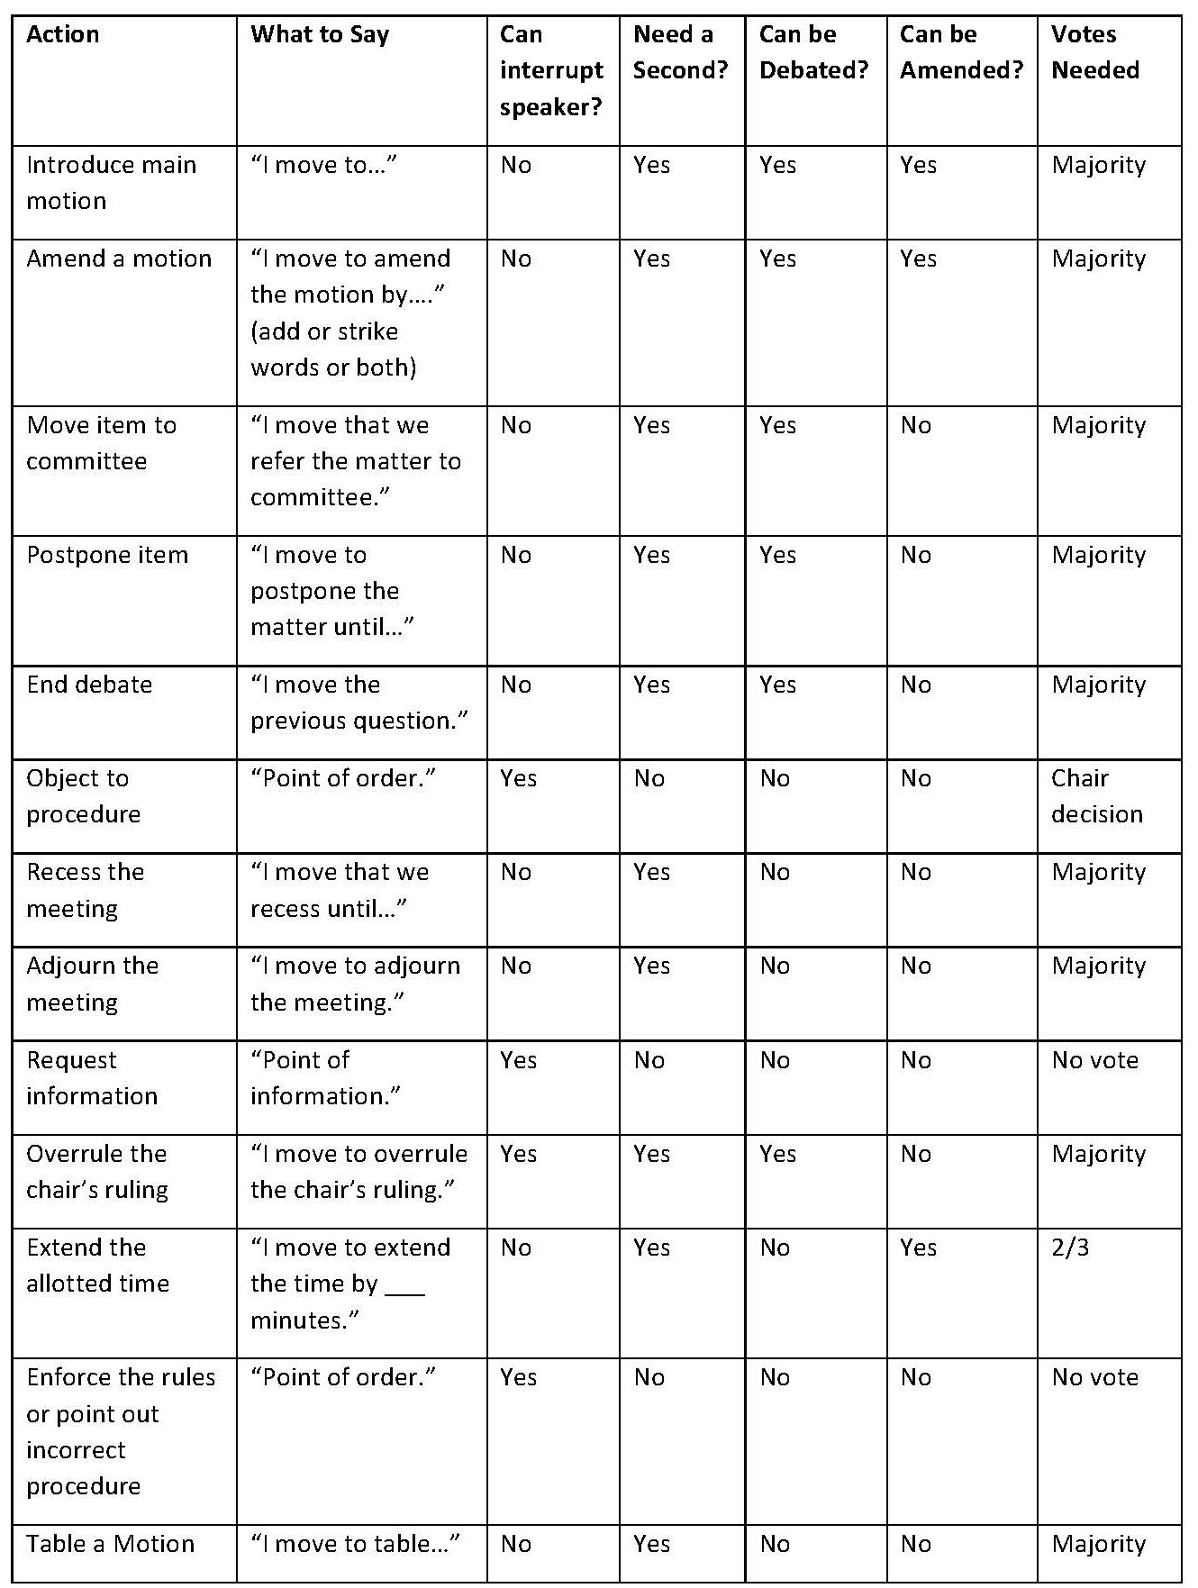

Agenda Template
(Sample Board Meeting Agenda Template)

EBHVIA Board of Directors
MEETING AGENDA
January 1, 2019
9:00 am
Founder’s Hall

- Call to Order by President
(welcoming remarks, introductions)

- Approval of the Agenda
(additions or deletions to agenda made now)

- Approval of the Minutes (corrections,*requires vote)

- Reports

  - Director’s Report
(review of projects, general outlook)
  - Treasurer’s Report
(summary of financial status, latest statement)
  - Buildings & Grounds Committee Report

  - (Ad Hoc) Committee Report

- Old Business
(discuss and resolve past business)
- New Business
(identify new business, create plan of action)
- Adjournment (*requires vote)

Next meeting date: Month, Day, Year
Respectfully submitted, (secretary)

Minutes

(add copy of most recent Annual Meeting Minutes)

Minutes can be found on the East Blue Hill web page:

www.eastbluehill.org

VIA Board of Directors 2021-22 Roster

(...add start year for all board members, also start date of officer terms)

Clifton Page, President (start date 2019)
Phil Norris, Vice President (start date 2019)
Jeanne Bourgault, Treasurer (start date 2019)
Kate Robinson, Secretary (start date 2019)

Clifton Page, President (start date 2019)
email
telephone

Phil Norris, Vice President (start dated 2021)
email
telephone

Kate Robinson, Secretary (start date 2019)
email
telephone

Jeanne Bourgault, Treasurer (start date 2019)
email
telephone

Randi Neblett (start date 2019)
amythest220@yahoo.com
telephone

Karen Milliken (start dated 2019)
email
telephone

Helen Westcott (start date 2017?)
helenowestcott@gmail.com
(609) 915-4721

Kathleen Gadsby (start dated 2021)
email
telephone

Theodore Wiggin (2021)
tekewiggin@me.com

Serena Evans (2021)
skimevans@aol.com

VIA Directory

(…add directory, or link)

History of EBHVIA

(Clifton?)

Town of Blue Hill Tax Map 25
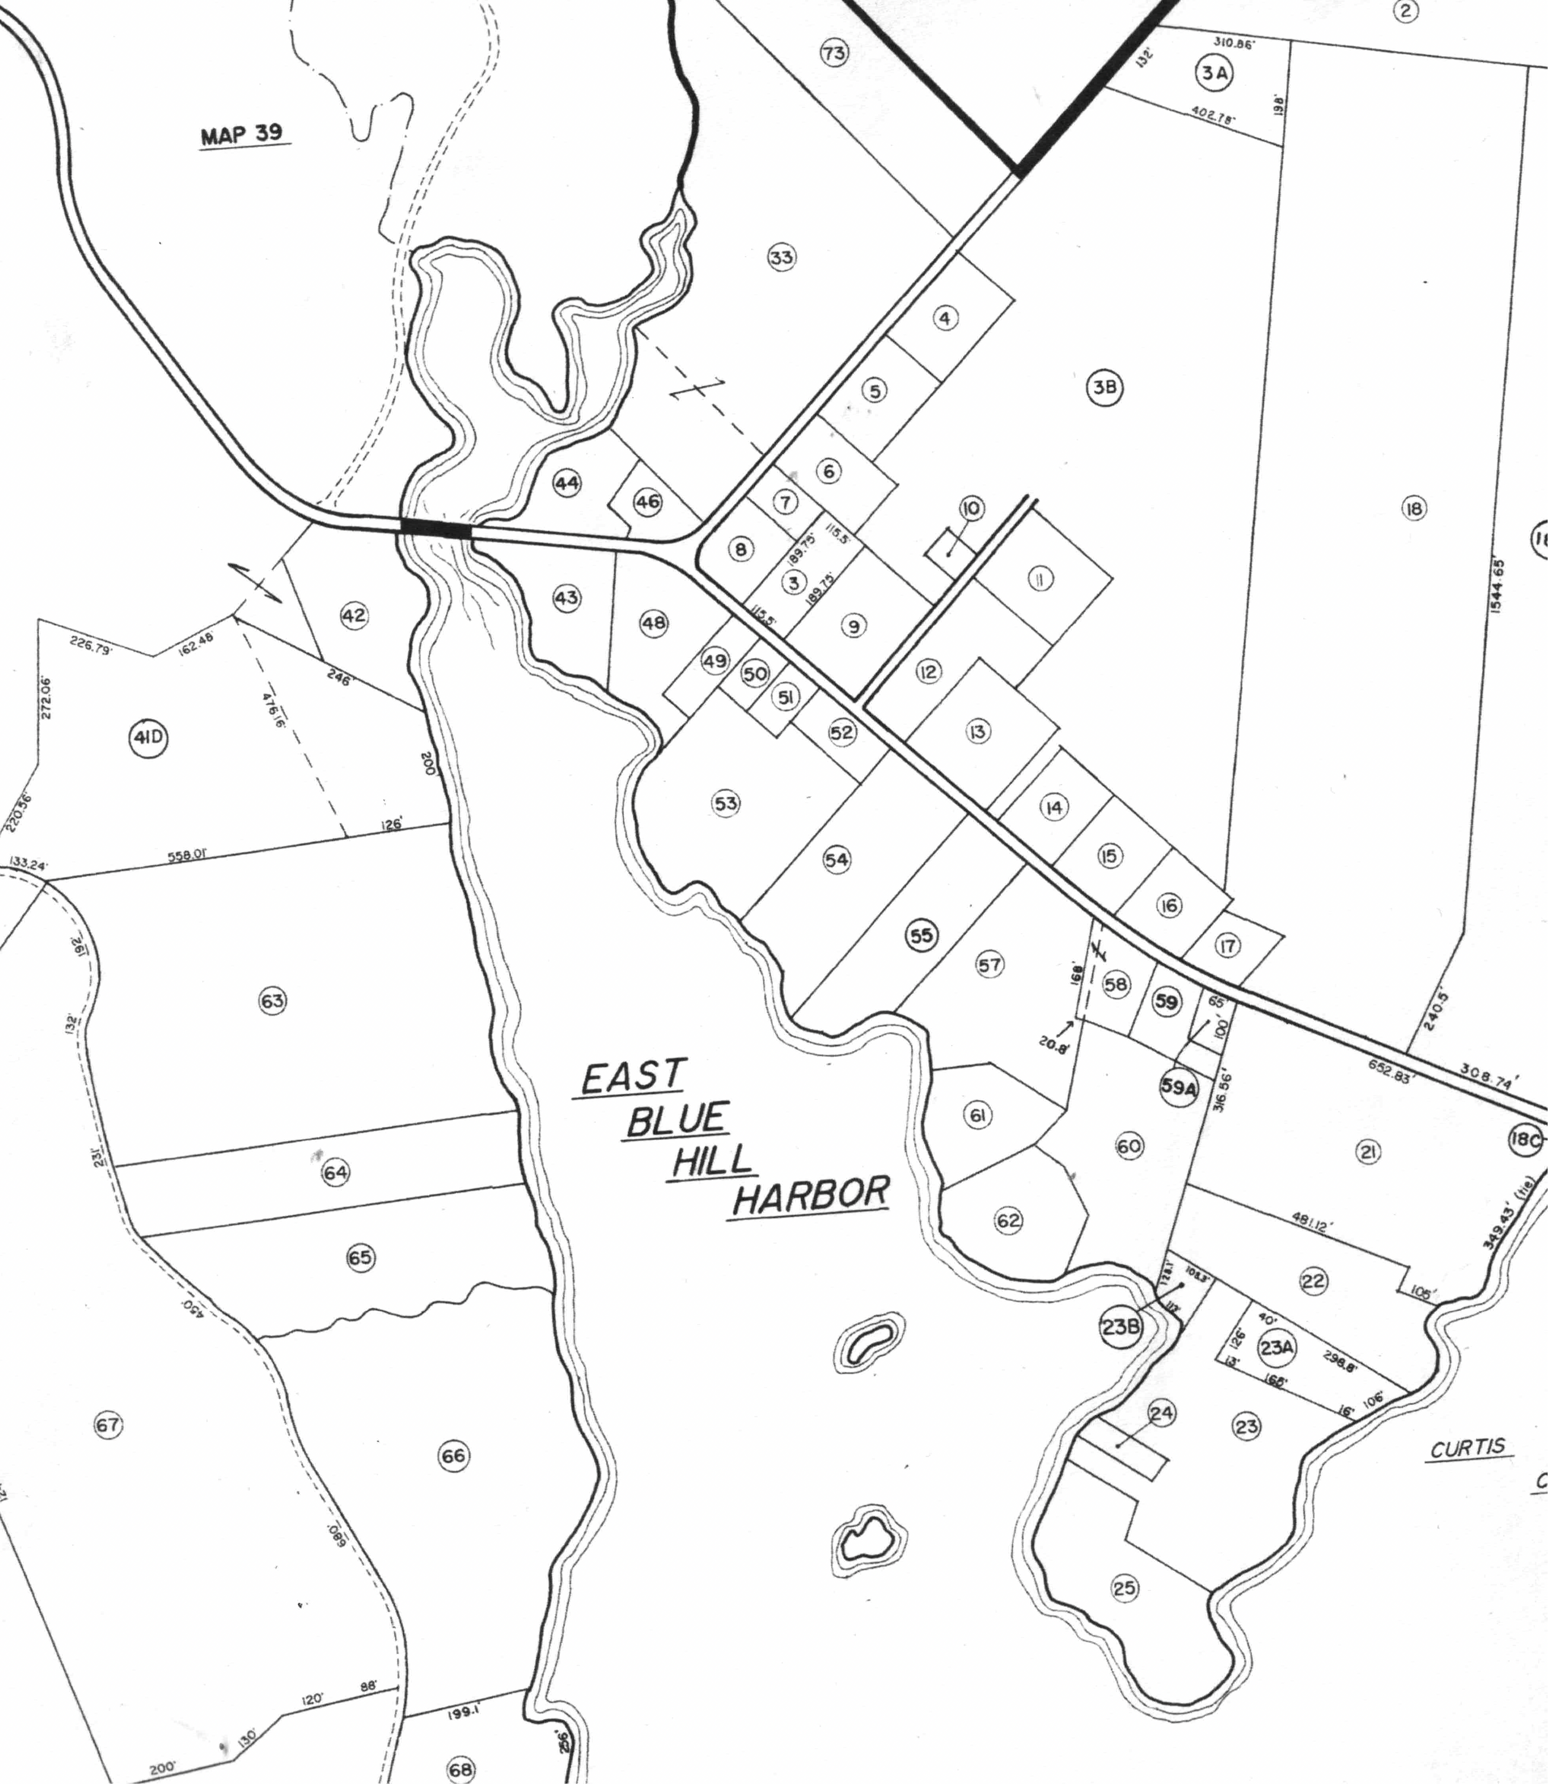

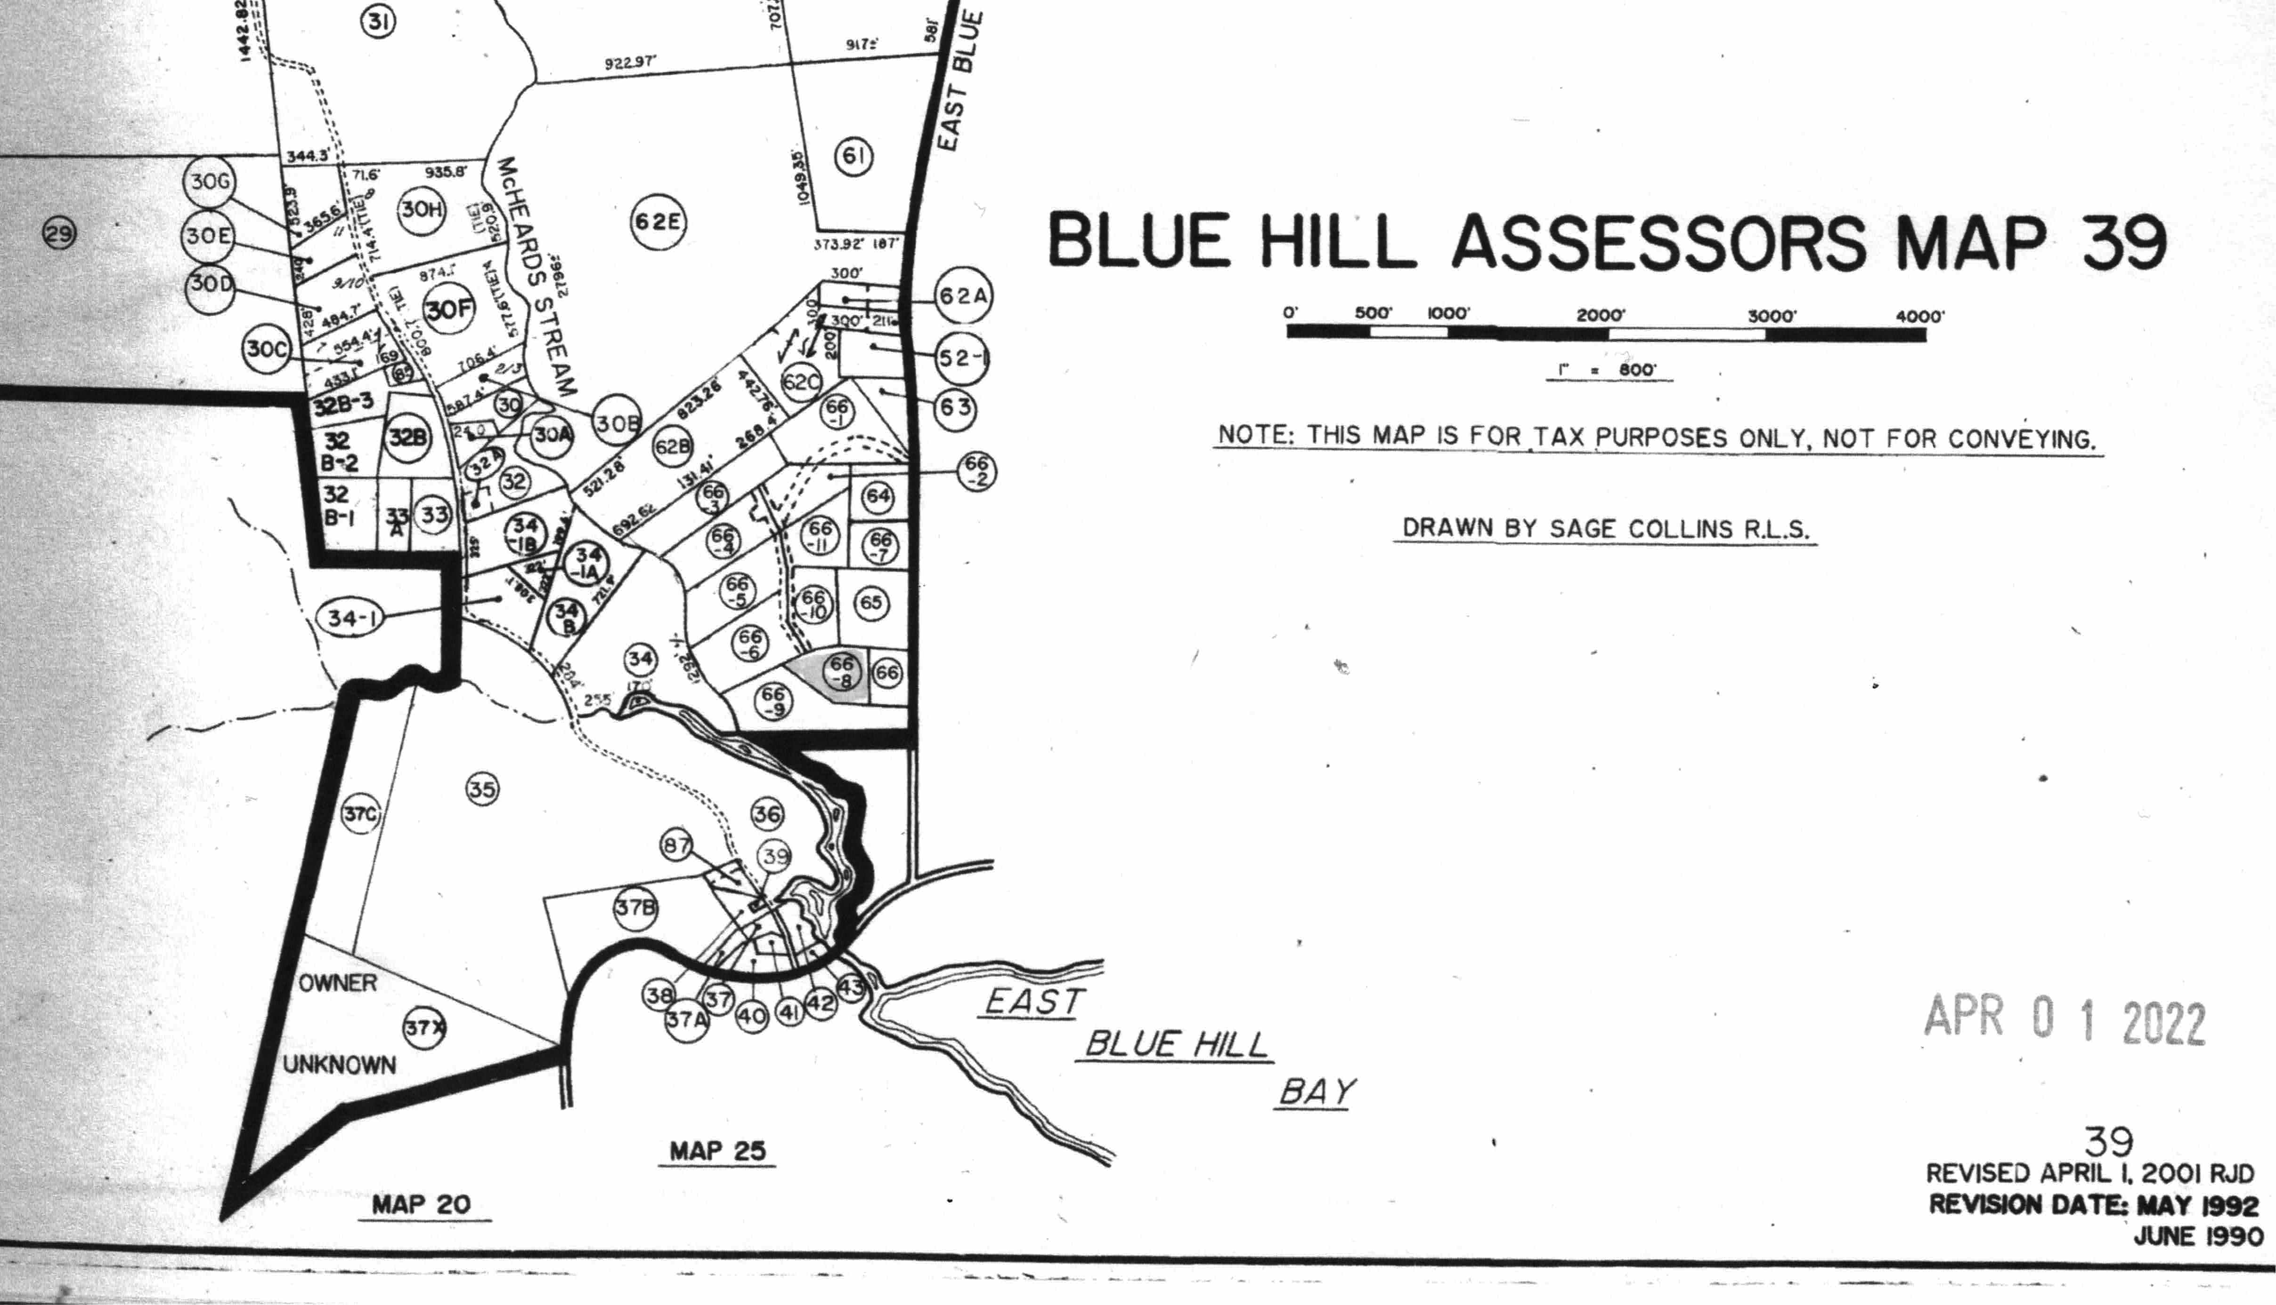

History of Village by Jerry Long

